RISK ASSESSMENT  Young People on site for activities |  | Assessed by: |  |  |  |  |  | Date: |  | Title of Assessment
 |  | Andy Shurey |  |  |  |  |  | 4/12/2021 |  | COVID-19: Young People undertaking activities on Silver Cross Scout Campsite - YELLOW |  |  |  |  |  |  |  | RA-CV-02
 |  |  |  |  |  |  |  | Version 5 |  | Consultation with the Site team & Publishing of this Assessment
 |  | Date to be reviewed |  |  |  |  |  | Gov. Updates / ScoutsCymru Updates |  | The final results of this risk assessment will be shared as appropriate.
 |  | Date of last review |  |  |  |  |  | 16.6.2021
 |  | Reviewed by |  |  |  |  |  | AS
Risk Controls to be Implemented By (Name) |  |  |  |  |  | Andy Shurey |  |  |  |  | Sign | A Shurey |  | Date |  | 4.12.2021
HAZARD | WHO AFFECTED |  | INITIAL RISK |  |  |  | RISK CATEGORY |  | EXISTING RISK CONTROLS |  |  |  | FURTHER RISK CONTROLS NECESSARY |  | RESIDUAL RISK |  |  | RESIDUAL RISK CATEGORY
 |  |  | L | S | R |  |  |  |  |  |  |  |  |  | L | S | R
Social Distancing on site  Failure to maintain compliance with social distancing during completion of the task resulting in increased risk of transmission. | Everyone on site |  | 4 | 5 | 20 |  | High |  | - The key objective is to maintain social distancing on site wherever possible.  - Everyone should remain at least two metres apart whilst on site wherever reasonably practical.  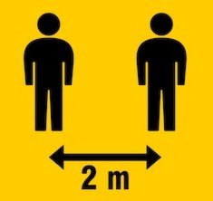  - Everyone will follow all site social distancing rules. |  |  |  | - Allocate specific areas to individual groups.  - Define permitted routes where practical  - Use "No Entry" signs and other signage as appropriate. |  | 2 | 5 | 10 | Medium

Coming to Site and Leaving Site | Everyone on site | 3 | 5 | 15 | High |  |  | 1 | 5 | 5 | Low
Failure to maintain compliance with social distancing during arrival and departure resulting in increased risk of transmission. |  |  |  |  |  | - Car sharing not be advised unless sharing with members of the same household.  - Arrivals to be staggered so social distancing is possible in the car park.  - Parents / guardians to remain in car and not wander around car park.  - Everyone is required to wash/sanitise their hands whenever entering or leaving the site.  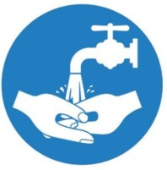  - Only the group sizes specified by HQ along with necessary site personnel.  - Everyone to maintain social distancing when accessing and leaving site – keeping 2m apart.

Moving around the Site  Failure to maintain compliance with social distancing during completion of the task resulting in increased risk of transmission. | Everyone on site | 4 | 5 | 20 | High | - Signage placed to give guidance 2 metre social distancing will be adhered to.  - Everyone required to stick to own designated areas and not encroach into areas where they are not allowed.  - Avoid congregating in groups such as waiting for toilets or arrival and departure from site | 1. Staff to continue to monitor the effectiveness of existing risk controls and amend as required. | 2 | 5 | 10 | Low

Toilet Areas: Failure to maintain compliance with social distancing and surface transmission prevention in the common areas resulting in increased risk of transmission.  Use of toilet block showers  Failure to maintain compliance with social distancing and surface transmission prevention in the shower areas resulting in increased risk of transmission. | Everyone on site | 3 | 5 | 15 | High | - Sanitise hands before entering the facilities  - Hand wash after every use of the toilet.  - Maximum of 2 people in gents’ and 2 in ladies’ at any one time  - Avoid contact with frequently touched surfaces where possible e.g.:  - Opening doors with feet/elbows or paper towels.  - Using tissue to switch off taps or contact surfaces.  - Toilet block cleaned prior to use as in Cleaning RA  - Those showering must enter shower area, use shower, dry and change and leave toilet block before next people showering can enter the area.  - After final persons showering, shower area to be cleaned using EC4 Sanitiser New Formulation following COSHH directions – see https://www.evansvanodine.co.uk/assets/eng_e-dose_EC4_sanitiser.pdf | - Staff to ensure that the welfare arrangements are being suitably managed (enhanced cleaning, signs, soap provision) prior to attending site.  - Provide hand sanitiser (minimum 60% alcohol based) to augment hand washing.  - Staff to ensure that the welfare arrangements are being suitably managed (enhanced cleaning, signs, soap provision) prior to attending site.  - Provide hand sanitiser (minimum 60% alcohol based) to augment hand washing.  - Leaders to ensure that correct numbers enter the shower area and follow the guidance re- maintaining social distancing, as given in point 3 opposite. | 2 | 5 | 10 | Medium
Common Areas: Car Parks  Failure to maintain compliance with social distancing in the car parks resulting in increased risk of transmission. | Everyone on site | 2 | 5 | 10 | Medium | - Everyone is required to maintain 2 metre separation in car park areas.  - Staggered arrival/departure times  - Car sharing not be advised unless sharing with members of the same household.  - Parents / guardians to remain in car and not wander around car park | 1. Staff to continue to monitor the effectiveness of existing risk controls and amend as required. | 1 | 5 | 5 | Low

Accidents, Security and Other Incidents | Everyone on site | 2 | 5 | 10 | Medium | - Ambulance to be called in a serious emergency.  - If possible you should wear a face mask, a plastic apron and disposable gloves before starting First Aid. You should also ask the injured person to wear a mask or face covering if possible (bear in mind that for some people this will not be possible or appropriate).  - If resuscitation is required or there is difficulty breathing e.g. asthma, choking or the person has a facial injury you should consider the following:  - If the person has breathing difficulties or a facial injury you should not ask them to wear a mask.  - If the person requires resuscitation then you should deliver this in accordance with the current government advice and using the techniques learnt in your first aid training. I  - Government guidance for first responders recommends chest compressions only for adults, but in children mouth to mouth with compressions is more likely to be required and so a face shield should be used where possible. The decision as to how to respond should be based on assessing the risks in each specific situation.  - For all other cases:  - Encourage the injured person | 1. Emergency plans including contact details should be kept up to date. | 1 | 5 | 5 | Low
Failure to manage appropriately/ attempting to maintain social distancing during accidents and incidents. |  |  |  |  |  |  | - Consideration must also be given to potential delays in emergency services response, due to the pressure on resources.  - If anyone develops symptoms of COVID- 19 or is observed to be displaying symptoms they should be removed from the activity area and:
 |  |  |  |  |  |  | - Parents called to collect immediately using the "In Touch" system.
 |  |  |  |  |  |  | - Parents then advised to adopt additional controls:
 |  |  |  |  |  |  | - Wear mask if available
 |  |  |  |  |  |  | - Keep windows open
 |  |  |  |  |  |  | - Keep distance (driver in front and passenger in rear)
 |  |  |  |  |  |  | - Clean down vehicle following transport.
 |  |  |  |  |  |  | - Contact emergency services if appropriate.
 |  |  |  |  |  |  | 4. Include the outside of first aid kits on regular sanitisation procedures.

to also wear a face mask or covering with due consideration to the situation and the age and level of distress of the individual affected.
b. Deliver first aid in accordance with your training.
- You should keep your mask on until the injured person is either handed over to the ambulance service or to a parent or guardian. Face masks, gloves, etc. should be bagged but can be disposed of in domestic waste. Bodily fluids can be cleaned up with disposable wipes and cleaned down with domestic cleaning products. Dispose of any cloths used for cleaning.
- Following treatment ensure you follow appropriate hygiene requirements i.e. wash hands, if not possible use generous amounts of sanitiser.
- Ensure you keep records as normal but also record anyone who has had to break social distancing.
If the injured person subsequently tests positive for COVID 19 then track and trace will ask the first aider to self-isolate
- In an emergency, for example a fire or accident There is no need to stay 2m
apart if it would be unsafe.

Cleaning the Facilities:  - General Cleaning | Everyone on site | 3 | 5 | 15 | High | - Standard cleaning products will be used as part of the enhanced cleaning programme.  - Everyone is required to maintain their allocated area in a clean and hygienic manner.  - Everyone will dispose of rubbish in appropriate manner. This should normally be in site skip.  - Contaminated (or suspected) rubbish should be double bagged to ensure separation.  - Gloves and masks to be worn whilst dealing with contaminated waste and also Selgiene cleaning materials and EC4 Sanitiser.  - Deep cleaning of Toilet Block – appropriate PPE must be worn – gloves, masks, disposable aprons – spray all surfaces with EC4 Sanitiser  - Use of Selgiene Extreme disinfectant must follow COSHH directions – see http://www.selden.co.uk/sdsarchive/SELDEN_C500_C500.pdf  - Use of EC4 Sanitiser New Formulation must follow COSHH directions – see https://www.evansvanodine.co.uk/assets/eng_e-dose_EC4_sanitiser.pdf | - Staff to introduce sanitisation and cleaning programme for appropriate parts of the site to include key touch points & areas such as:  - Door handles  - Door push plates  - Light switches  - First aid kit containers  - W/C handles  - Taps  - Soap dispensers  - W/Cs | 2 | 5 | 10 | Medium
- Handwashing
- Sanitation Facilities
- Toilets
Failure to reduce transmission through contact with contaminated surfaces by not keeping the workplace clean.
General Hygiene:  - Handwashing  - Sanitation Facilities | Everyone on site | 3 | 5 | 15 | High | - Regular hand washing to be undertaken throughout the day.  - Avoid Greetings: Avoid physical greetings (hand shaking etc).  - Avoid Skin Contact: Avoid touching eyes, nose and mouth. | 1. Keep comprehensive records of attendees so that Track and Trace can be used efficiently should a suspected case of Covid-19 occur. | 2 | 5 | 10 | Medium
- Toilets |  |  |  |  |  |  | 2. Provide sanitising stations throughout the site.
Failure to reduce transmission through contact with contaminated surfaces or direct exposure to airborne particulates by not enforcing good hygiene practices.

- Practice respiratory hygiene: This means covering your mouth and nose with your bent elbow or tissue when you cough or sneeze. Then dispose of the used tissue immediately.

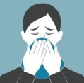
- Everyone must use hand sanitiser when entering and leaving the site.

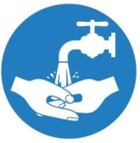
- Wash or sanitise hands before and after using the site W/C facilities.

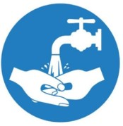
- Avoid contact with frequently touched surfaces where possible e.g.:
  - Opening doors with feet/elbows.
  - Using tissue to switch off taps or contact surfaces.

- Any surfaces recently contacted by affected individuals to be isolated and thoroughly cleaned in line with current guidance at: https://gov.wales/sites/default/files/publications/2020-07/operational-guidance-for-schools-and-settings-from-the-autumn-term.pdf?fbclid=IwAR39vEJAw7UM5ekQY_Qf_W-C0e60tyyQYWZ0vfoR_zFsiBYSn_BLZE63gqc
- If anyone on site has helped someone who was taken unwell with a new, continuous cough or a high temperature, they do not need to immediately go home unless they develop symptoms themselves. They should wash their hands thoroughly for 20 seconds after any contact with someone who is unwell with symptoms consistent with coronavirus infection.
- If waste is considered to be contaminated with Covid-19 virus, remove and place into a plastic bag any wipes, disposable gloves and overalls used, whilst trying not to cross-contaminate onto existing clothes or persons.
- Waste should be double bagged and sealed.

Use of hand sanitiser and washing facilities | Everyone on site | 3 | 5 | 15 | High | - Signage placed to give guidance of position of hand sanitiser stations.  - Sanitising stations placed at entrance to site (on shop verandah), entry to Toilet Block, Pembroke Building  - Hand sanitiser supplied on every activity area  - Hand soap supplied to each available hand basin in the toilet block and in the Pembroke Building | - Staff to regularly check that supplies of soap and sanitiser are in place  - Staff to replace/refill sanitiser and soaps when needed | 1 | 5 | 5 | Low
Ensuring sufficient supply of hand sanitiser and soap |  |  |  |  |  | .

Use of hand sanitiser and washing facilities
Ensuring sufficient supply of hand sanitiser and soap

Using Indoor Facilities - Pembroke Building  Ensuring sufficient supply of hand sanitiser and soap  Insufficient ventilation in building | People using the Pembroke Buidling | 3 | 5 | 15 | High | - Standard cleaning products, including Selgiene, will be used as part of the enhanced cleaning programme.  - Everyone is required to maintain their allocated area in a clean and hygienic manner.  - Everyone will dispose of rubbish in appropriate manner. This should normally be in site skip.  - Pembroke Building to be cleaned regularly, including all touch points (handles, light switches etc). Whole building interior to be spray cleaned with EC4 Sanitiser.  - Appropriate PPE for cleaning must be worn – gloves, masks, disposable aprons  - Use of Selgiene Extreme disinfectant must follow COSHH directions – see http://www.selden.co.uk/sdsarchive/SELDEN_C500_C500.pdf  - Use of EC4 Sanitiser New Formulation must follow COSHH directions – see https://www.evansvanodine.co.uk/assets/eng_e-dose_EC4_sanitiser.pdf  - Where possible, users to operate a 1 way system of entry and exit, using main doors as entrance and fire exit in main room as the exit.  - Hand sanitiser station placed in foyer of building at the main entrance.  - When in use, the windows in the rooms being used must be opened to allow through flow of air to minimise chance of infection from Covid-19  - Where possible, social distancing of 2m should be observed at all times. Scouts, Explorers and Adults must wear face mask indoors. Cubs and Beavers do not need to wear masks or observe 2m distancing.  - Maximum number overnight 24 | - Staff to regularly check that supplies of soap and sanitiser are in place  - Staff to replace/refill sanitiser and soaps when needed | 1 | 5 | 5 | Low
 |  |  |  |  |  | .

Using Indoor Facilities – Soft Crossbows Range  Insufficient ventilation inside Range | Everyone on site | 3 | 5 | 15 | High | - Soft Crossbow Range to be cleaned before and after each use, including all touch points (handles, light switches etc), spray cleaned with EC4 Sanitiser.  - Appropriate PPE for cleaning must be worn – gloves, masks, disposable aprons  - Use of Selgiene Extreme disinfectant must follow COSHH directions – see http://www.selden.co.uk/sdsarchive/SELDEN_C500_C500.pdf  - Use of EC4 Sanitiser New Formulation must follow COSHH directions – see https://www.evansvanodine.co.uk/assets/eng_e-dose_EC4_sanitiser.pdf  - Hand sanitiser supplied at entrance to Range, participants to use on entry.  - Social distancing of 2m is difficult within the Range. Scouts, Explorers and Adults must wear face masks. Cubs and Beavers do not need to wear masks.  - With Cubs and Beavers, maximum in range at any time is 10 plus leaders. With Scouts and Explorers, 3 shooters plus leader/s in range plus rest of group waiting outside range, socially distanced.  - The indoor range is naturally ventilated with fresh air via floor slats because of its construction. However, the main door should also be secured in an open position while the range is in use.  - Any persons waiting to take part should wait outside and on the verandah to the shop. No persons to wait on the approach gangway. | - Staff to regularly check that supplies of sanitiser are in place  - Staff to replace/refill sanitiser when needed | 1 | 5 | 5 | Low
 |  |  |  |  |  | .

RISK |  | Severity | 5 | 10 | 15 | 20 | 25
 |  |  | 4 | 8 | 12 | 16 | 20
LIKELIHOOD | SEVERITY |  | 3 | 6 | 9 | 12 | 15
1. Extremely Unlikely | 1. Minor Injury/disease no lost time |  | 2 | 4 | 6 | 8 | 10
2. Unlikely | 2. Injury/disease up to 7 days lost |  | 1 | 2 | 3 | 4 | 5
3. Likely | 3. Reportable under RIDDOR over 7 days |  | Likelihood
4. Very Likely | 4. Specified Injury/Long term absence | Low |  | Medium |  | High
5. Almost Certain to happen | 5. Death | 1-8 |  | 9-12 |  | 15-25

References used in the development of this risk assessment:
- https://gov.wales/coronavirus
- https://gov.wales/volunteering-third-sector-coronavirus
- https://www.nhs.uk/conditions/coronavirus-covid-19/check-if-you-have-coronavirus-symptoms/
- www.scouts.org.uk/coronavirus
- https://gov.wales/sites/default/files/publications/2020-07/operational-guidance-for-schools-and-settings-from-the-autumn-term.pdf?fbclid=IwAR39vEJAw7UM5ekQY_Qf_W-C0e60tyyQYWZ0vfoR_zFsiBYSn_BLZE63gqc
- https://scoutscymru.org.uk/members/coronavirus-support/
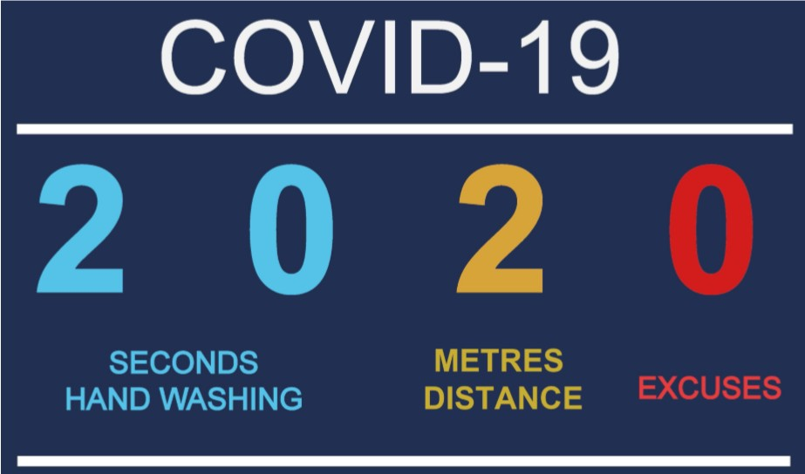

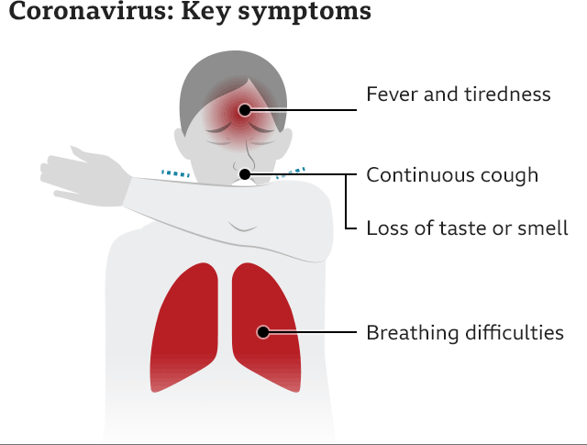
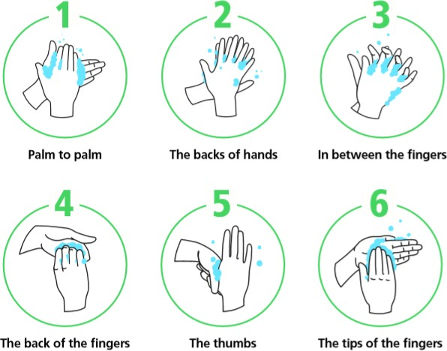
Key COVID-19 Symptoms & Controls:
Note: DO NOT ATTEND SITE – a) if you are unwell/displaying symptoms b) if someone in your household is self-isolating
Symptoms: Hand Washing:

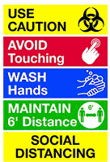

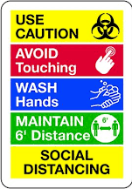

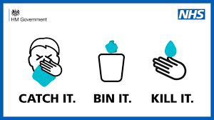

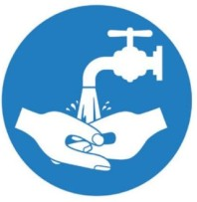
General Safe systems for use during the COVID-19 Pandemic
NOTE: These guidance notes will be updated whenever Government and Scouting advice changes/
The points below are provided to help keep everyone visiting site safe during the Covid-19 pandemic. They are based on Government and Scouting recommendations, which may change frequently: www.gov.uk/coronavirus, wwww.scouts.org.uk/coronavirus
We will endeavour to update our guidance in line with current Government and Scouting recommendations.

Key Considerations:
- Everyone must protect themselves always remembering the wellbeing of others on site as appropriate.
- Do not shake hands with any other person at the site. Avoid ALL physical contact.
- Wash/sanitise your hands thoroughly for at least 20 seconds, on arrival and frequently during the activity, before and after using toilet.
- Use soap and warm water when washing hands
- Use an alcohol-based hand sanitiser that contains at least 60% alcohol if soap and water are not available.
- Avoid touching your eyes, nose, and mouth at all times.
- Do not attend if you are unwell/displaying symptoms
- If someone in your household is self-isolating consider whether it is wise to attend.

Arrival at Site:
- Wash your hands with soap and water for at least 20 seconds. Where facilities to wash hands are not available, hand sanitiser should be used.
- Do not enter site if you are feeling unwell or displaying symptoms of Covid-19 e.g. high temperature/cough/breathing difficulties.
- Observe site social distancing measures as soon as you arrive on site (parking area onwards).
- Use dedicated site access points.

During Time on Site:
- Maintain social distancing (minimum two metres apart) at all times.
- If for any reason social distancing cannot be followed a mask must be used
- Avoid skin-to-skin and face-to-face contact.
- Avoid entering buildings other than toilets.
- When using toilets remember to obey hygiene guidelines

When Leaving Site:
- Deposit any rubbish into site bins
- Before leaving site use an alcohol-based hand sanitiser that contains at least 60% alcohol if more convenient.

The contents of this risk assessment and the resulting Safe System of Work should be shared as appropriate to its contents.
This risk assessment will be shared with all pertinent staff at Silver Cross and available to any groups wishing to attend the site.
All Silver Cross staff will be aware of Scouting rules on safeguarding, safety and GDPR.

